Dungeon Front Lower Wall:

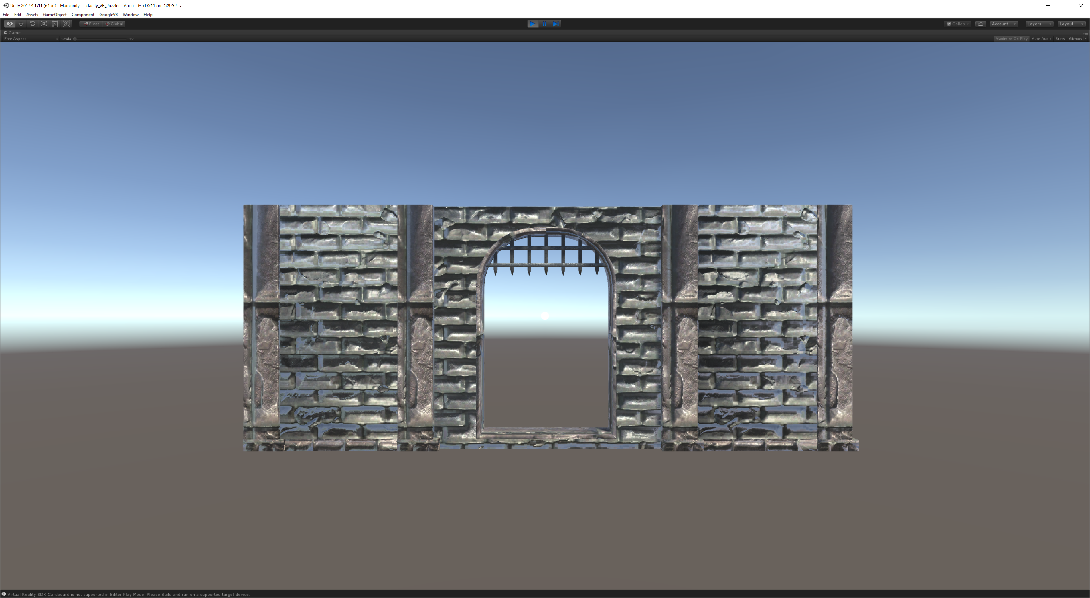

Dungeon Front

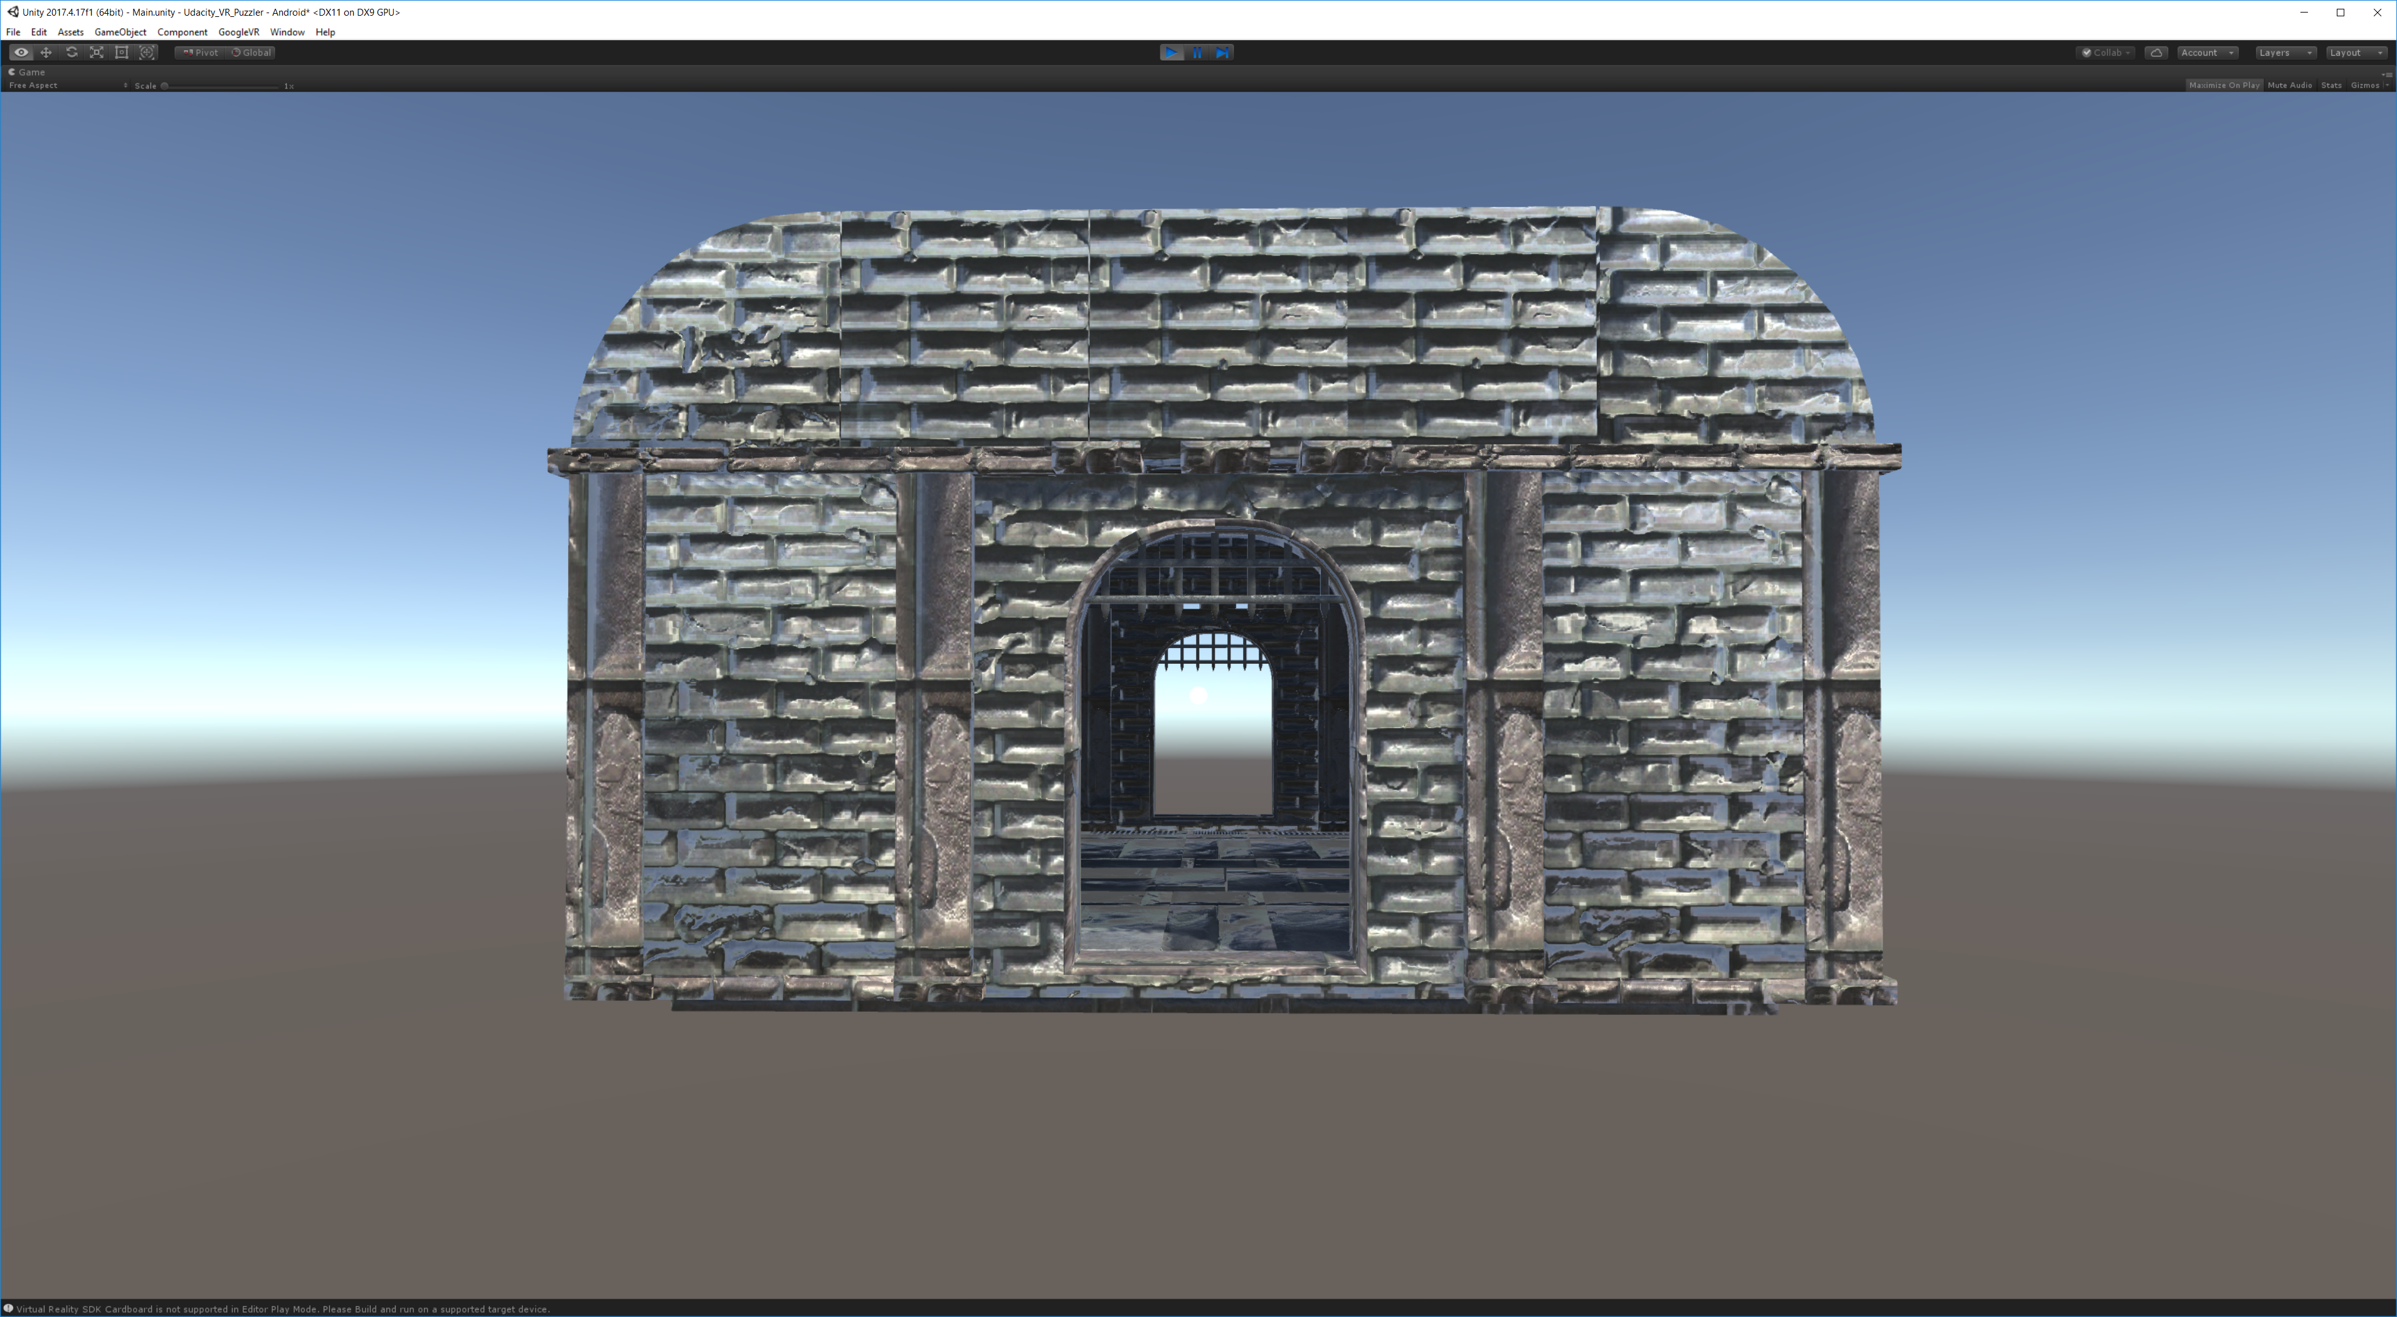

Dungeon inside

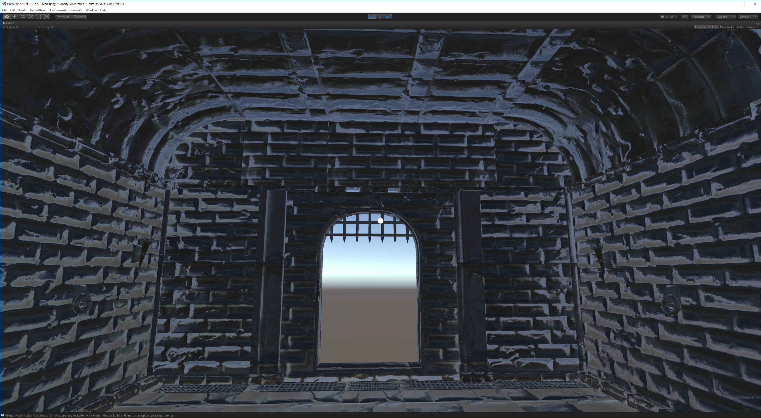

Dungeon inside looking left:

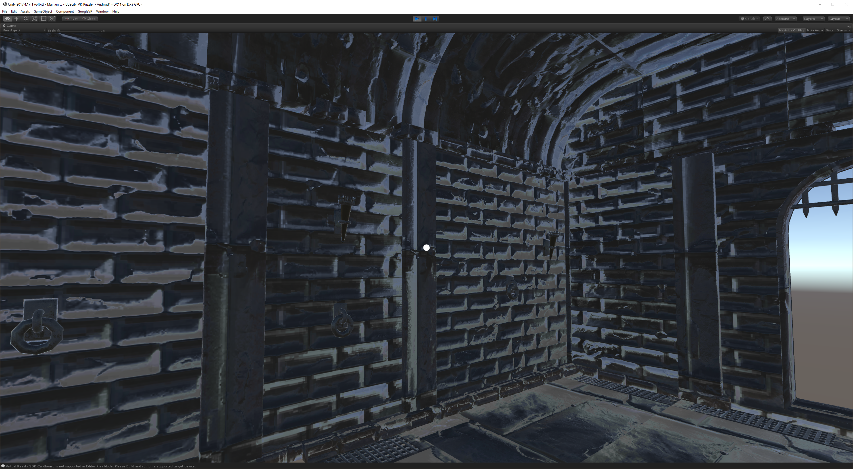

Dungeon inside looking right:

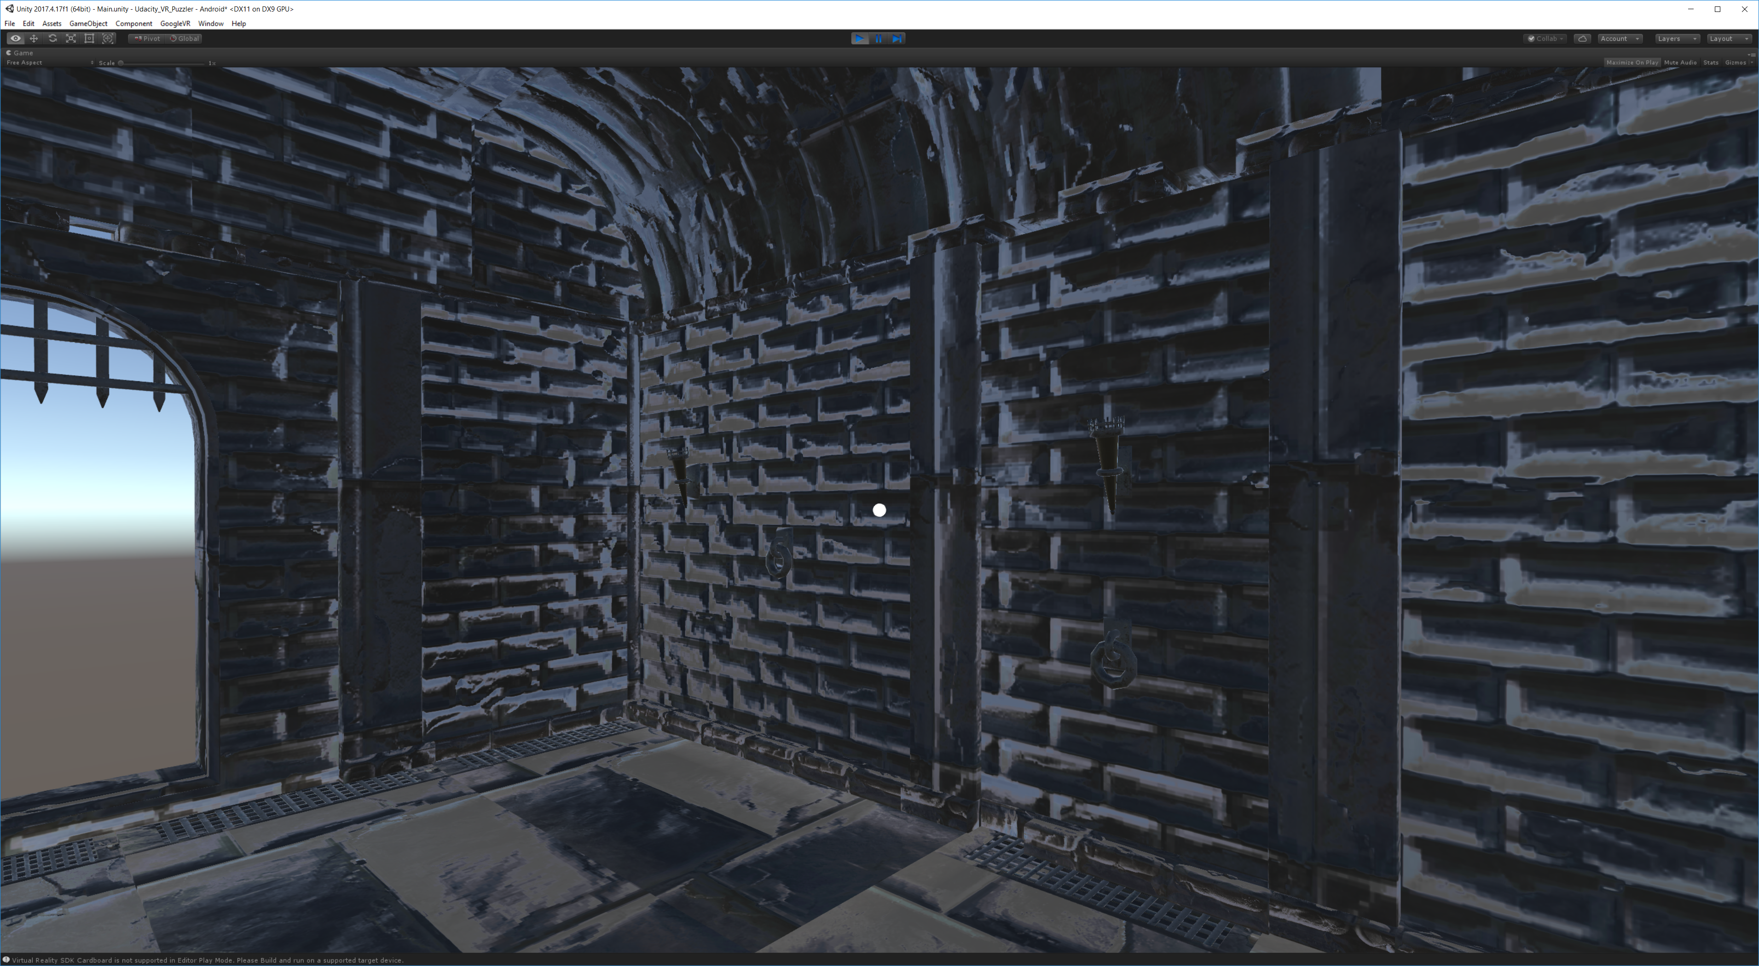

Dungeon inside looking up:

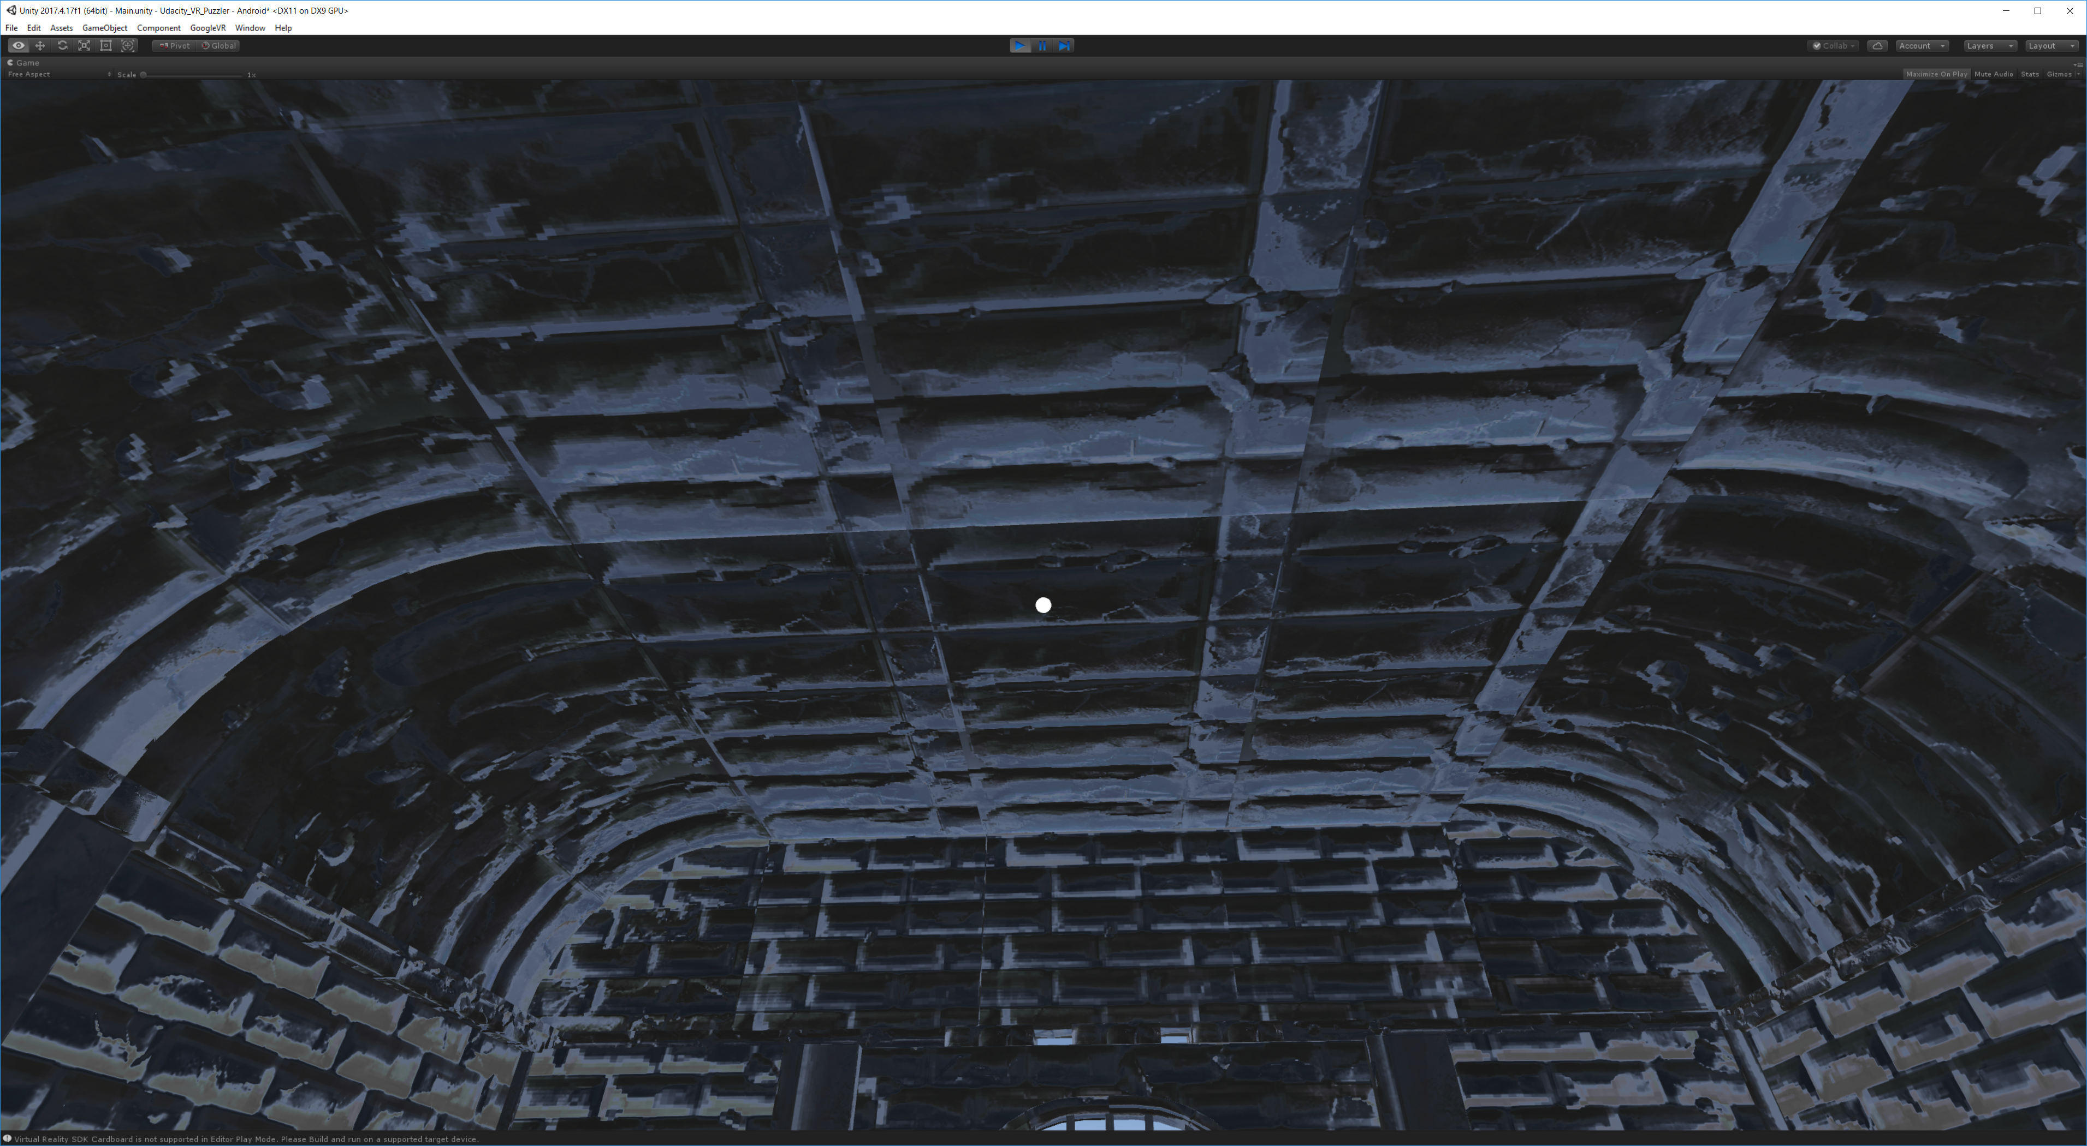

Dungeon inside with orbs: Deployed the orbs seem a little close. However, this will be resolved when we set up our waypoint.

